LAB # 5

INHERITANCE TYPES

OBJECTIVE
- To be able to create new classes by applying different types of inheritance.

THEORY

Types of inheritance:
The c++ classes can be derived in several ways.
- Hierarchical Inheritance.
- Multiple Inheritances.
- Multi Level Inheritance.
- Hybrid or Multi-path Inheritance.

Hierarchical Inheritance
In Object Oriented Programming, the root meaning of inheritance is to establish a relationship between objects. In Inheritance, classes can inherit behavior and attributes from pre-existing classes, called Base Classes or Parent Classes. The resulting classes are known as derived classes or child classes.
So in Hierarchical Inheritance, we have 1 Parent Class and Multiple Child Classes, as shown in the pictorial representation given on this page, Inheritance. Many programming problems can be cast into a hierarchy where certain features of one level are shared by many others below that level.

In C++, such problems can be easily converted into hierarchies. The base class will include all the features that are common to the subclasses. A subclass can be constructed by inheriting the properties of the base class. A subclass can serve as a base class for the lower-level classes and so on.

A derived class with hierarchical inheritance is declared as follows:

class A {…..}; // Base class
class B: public A {…..}; // B derived from A class C: public A {…..}; // C derived from A

In this type of inheritance, more than one sub class is inherited from a single base class. i.e. more than one derived class is created from a single base class.
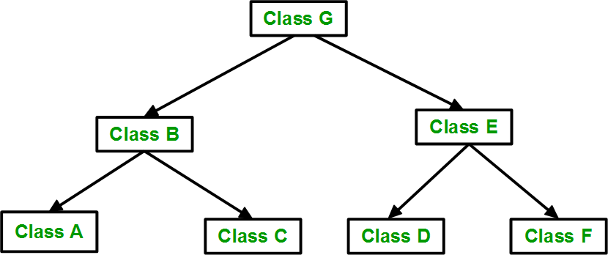
Fig: Hierarchical Inheritance

Practice Example 1:
Suppose, you want to calculate either area, perimeter or diagonal length of a rectangle by taking data (length and width) from user. You can create three different objects (Area, Perimeter and Diagonal) and asks user to enter length and width in each object and calculate corresponding data.
But, the better approach would be to create an additional class Rectangle to store value of length and width from user and derive classes Area, Perimeter and Diagonal from Rectangle base class. It is because, all three classes Area, Perimeter and diagonal are related to class Rectangle and you don't need to ask user the input data from these three derived classes as this feature is included in base class.
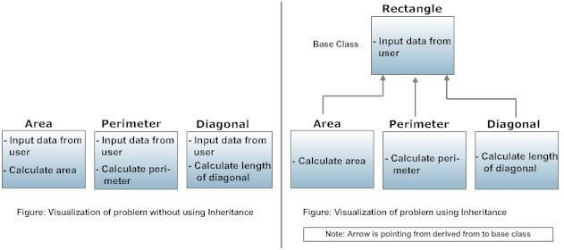
#include <iostream> using namespace std; class Rectangle
{
protected:
float length, width; public:
Rectangle()
{
cout<<"Enter length: "; cin>>length; cout<<"Enter width: "; cin>> width;
}
};

/* Area class is derived from base class Rectangle. */ class Area : public Rectangle
{
public:
float calc()
{
return length*width;
}
};

/* Perimeter class is derived from base class Rectangle. */ class Perimeter : public Rectangle
{
public:
float calc()
{
return 2*(length+width);
}
};

int main()
{
cout<<"Enter data for first rectangle to find area.\n"; Area a;
cout<<"Area = "<<a.calc()<<" square meter\n\n";
cout<<"Enter data for second rectangle to find perimeter.\n"; Perimeter p;
cout<<"\nPerimeter = "<<p.calc()<<" meter"; return 0;
}

Practice Example 2:
#include<iostream> using namespace std;
class A
{
protected:
char name[20]; int age;
};

class B:public A
{
public:
float h; int w; void get_data1()
{
cout<<"Enter name:"; cin>>name;
cout<<"Enter weight and height:"; cin>>w>>h;
}
void show()
{
cout<<"This is class B and it is inherited from Class A\n"; cout<<"Name: "<<name<<endl; cout<<"Weight: "<<w<<endl; cout<<"Height: "<<h<<endl;
}
};

class C:public A

{
public:
char gender; void get_data2()
{
cout<<"Enter age:"; cin>>age; cout<<"Enter gender:"; cin>>gender;
}
void show()
{
cout<<"This is class C and it is inherited from class A\n"; cout<<"Age: "<<age<<endl; cout<<"Gender: "<<gender<<endl;
}
};

int main()
{
B ob1; C ob2; ob1.get_data1(); ob2.get_data2(); ob1.show();
ob2.show();
}

Output:
Enter name: Ahmed
Enter weight and height: 63 5.8
Enter age: 26 Enter gender: M
This is class B and it is inherited form class A Name: Ahmed Weight: 63
Height: 5.8
This is class C and it is inherited form class A Age: 26 Gender: M

Multiple Inheritances
Multiple inheritance is a feature of some computer programming languages in which an object or class can inherit characteristics and features from more than one parent class. It is distinct from single inheritance, where an object or class may only be inherited from one particular object or class.
Multiple Inheritance has been a sensitive issue for many years, with opponents pointing to its increased complexity and ambiguity in situations such as the “diamond problem”, where it may be ambiguous as to which parent class a particular feature is inherited from if more than one parent class implements said feature. This can be addressed in various ways, including using virtual Inheritance.
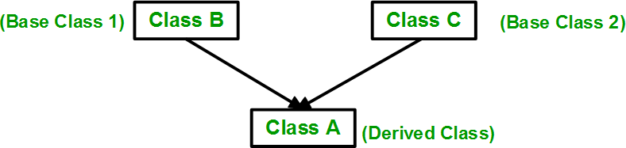

In the above figure the class A is deriving from class B and class C. The syntax for multiple Inheritance is similar to that for single Inheritance. In this situation the relationship is expressed like this

Class B // base class B
{
};
Class C // base class C
{
};
Class A: public B, public C // A is derived from B and C
{
};

Practice Example 2:
#include<iostream> using namespace std;
class A
{
protected:
char name[20]; int age;
};
class B
{
protected:
int w; float h;
};

class C: public A,B
{
public:
char g;
void get_data()
{
cout<<"Enter name and age:\n"; cin>>name>>age;
cout<<"Enter weight and height:\n"; cin>>w>>h; cout<<"Enter gender: "; cin>>g;
}
void show()
{
cout<<"\nName: "<<name<<endl<<"Age: "<<age<<endl; cout<<"Weight: "<<w<<endl<<"Height: "<<h<<endl; cout<<"Gender: "<<g<<endl;
}
};

int main()
{
C ob;

ob.get_data(); ob.show();
}

Output:
Enter name and age: Ahmed 31
Enter weight and height: 64 5.9
Enter gender: M
Name: Ahmed Age: 31
Weight: 64
Height: 5.9 Gender: M

Multi-level inheritance
Inheritance is the process of inheriting properties of objects of one class by objects of another class. The class which inherits the properties of another class is called Derived or Child or Sub class and the class whose properties are inherited is called Base or Parent or Super class. When a class is derived from a class which is also derived from another class, i.e. a class having more than one parent classes, such inheritance is called Multilevel Inheritance. The level of inheritance can be extended to any number of level depending upon the relation. Multilevel inheritance is similar to relation between grandfather, father and child.
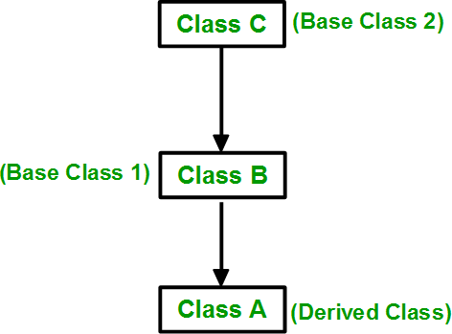
Fig: Multilevel inheritance
Practice Example 3: #include<iostream> using namespace std;

class A
{
protected:
char name[20]; int age;
};

class B:public A
{
protected: int w; float h;
};

class C:public B

{
public:
char g;
void get_data()
{
cout<<"Enter name and age:\n"; cin>>name>>age;
cout<<"Enter weight and height:\n"; cin>>w>>h;
cout<<"Enter gender:"; cin>>g;
}
void show()
{
cout<<"\nName: "<<name<<endl<<"Age: "<<age<<endl; cout<<"Weight: "<<w<<endl<<"Height: "<<h<<endl; cout<<"Gender: "<<g<<endl;
}
};

int main()
{
C ob; ob.get_data(); ob.show();
}

Output:
Enter name and age: Ahmed 35
Enter weight and height: 58 5.6
Enter gender: M Name: Ahmed Age: 35 Weight: 58
Height: 5.6 Gender: N

Practice Example 4:
Write a C++ program to create multilevel inheritance. (Hint: Classes A1, A2, A3)

#include <iostream> using namespace std;

class base //single base class
{
public:
int x;
void getdata()
{
cout << "Enter value of x= "; cin >> x;
}
};

class derive1 : public base // derived class from base class

{
public:
int y;
void readdata()
{
cout << "\nEnter value of y= "; cin >> y;
}
};

class derive2 : public derive1 // derived from class derive1
{
private:
int z; public:
void indata()
{
cout << "\nEnter value of z= "; cin >> z;
}

void product()
{
cout << "\nProduct= " << x * y * z;
}
};

int main()
{
derive2 a; a.getdata();
a.readdata();
a.indata();
a.product(); return 0;
}

Output:
Enter value of x= 2 Enter value of y= 3 Enter value of z= 3 Product= 18

Hybrid inheritance
Hybrid inheritance is combination of two or more types of inheritance. It can also be called multi path inheritance.
For example, the diagram below shows both Hierarchical Inheritance and multi level inheritance.
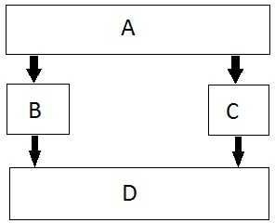

Practice Example 5: include<iostream> using namespace std;

class A //Base class
{
public:
int l;
void len()
{
cout<<"Lenght: ";
cin>>l; //Lenght is enter by user
}
};

class B :public A //Inherits property of class A
{
public:
int b,c;
void l_into_b()
{
len(); cout<<"Breadth: ";
cin>>b; //Breadth is enter by user
c=b*l; //c stores value of lenght * Breadth i.e. (l*b).
}
};
class C :public A //Inherits property of class A
{
public:
int h;
void height()
{
cout<<"Height: ";
cin>>h; //Height is enter by user
}
};

class D: public B,public C //Hybrid Inheritance Level
{
public:
int res;
void volume()
{
l_into_b(); height(); res=h*c;
cout<<"Volume is (l*b*h): "<<res<<endl;
}
void area()
{

l_into_b();
cout<<"Area is (l*b): "<<c<<endl;
}
};

int main()
{
D d1;
cout<<"Enter dimensions of object to get Area:\n"; d1.area();
cout<<"Enter values of object to get Volume:\n"; d1.volume(); return 0;
}

OUTPUT:
Enter dimensions of object to get Area: Length: 63 Breadth: 23
Area is (l * b): 1449
Enter dimensions of object to get Volume: Length: 12 Breadth: 27
Height: 14
Volume is (l * b * h): 4536

Lab Tasks:
- Write down a program using multiple inheritance, using following scenario.
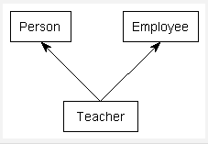

- Consider four classes named Animal, Mammal, Bird, and Bat.
  - class Animal that includes the functionality of eating and breathing
  - class Mammal derived from Animal class and has additional functionality of giving birth but not hatching
  - class Bird derived from Animal class and has specific functionality of flying

class Bat derived from both Animal and Bird classes while inheriting the functionality of both these classes
Draw UML diagram for each class and show inheritance relationship between these classes. Moreover, illustrate the implementation of these classes in C++.

- Define a class Student as a base class with data members as admissionNo, Name, age and address as protected type and getStudent function for setting values for these data members. These members and functions are common to both derived classes. Make two derived classes of Student class as

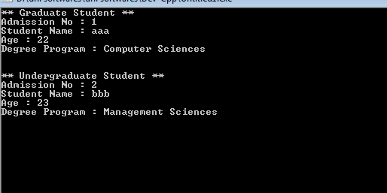
undergraduate and graduate student each containing data member degree_program "in which student is enrolled" and member functions getdegree "set degree_program" and show "display whole information". Degree in which student is enrolled and display the whole information of graduate and undergraduate student like this

- By using multiple inheritance, make a student class representing student with data member roll_no and two member functions get_roll_no to get and display_roll_no to display roll number of student. A test class (derived class of student) representing the scores of the student in two subjects and sports class (derive class of stu) representing the score in sports. The sports and test class should be inherited by a result class having the functionality to add the scores of two subjects and sports score an then display the final result for students.

Lab Outcomes:
- Student become familiar with the types of Inheritance.
- Student become familiar with how to utilize inheritance.

LAB # 6

Friend Functions

OBJECTIVE
  - To be able to use Friend Functions

THEORY

Friend Functions:
A C++ friend functions are special functions which can access the private members of a class.
A friend function of a class is defined outside that class' scope but it has the right to access all private and protected members of the class. Even though the prototypes for friend functions appear in the class definition, friends are not member functions.
Note that friend declarations can go in either the public, private, or protected section of a class--it doesn't matter where they appear.

- Friend function must be declared with friend keyword.
- Friend function must be declared in all the classes from which we need to access private or protected members.
- Friend function will be defined outside the class without specifying the class name.
- Friend function will be invoked like normal function, without any object.

Practice Example 1:
// C++ program to demonstrate friend function
// Access private member variable

#include <iostream> using namespace std;
class Demo { private:
int a, b, c;
friend int dostFunction(Demo);
};

int dostFunction(Demo x)
{
x.a = 2;
x.b = 3;
x.a = x.a + x.b;
return (x.c);
}

int main() { Demo obj;

cout<<dostFunction(obj); return 0;
}

Practice Example 2:
// C++ program to demonstrate friend function
// Access private member function

#include <iostream> using namespace std;
class Demo { private:
int a, b;

void test(){ cout<<"Enter two no. : "; cin>>a>>b;
cout<<a+b;
}
friend void dostFunction(Demo); // comment
};

void dostFunction(Demo x) // obj create of demo class
{
x.test(); // when f fn run it call test fn and access test private fn
}

int main() { Demo obj;
dostFunction(obj); return 0;
}

Practice Example 3:
// C++ program to demonstrate friend function of two class

#include <iostream> using namespace std;

class Xyz: // forward declaration optional class Abc{
private:
int a;

friend void dostFunction(Abc,Xyz); //friend function
};

class Xyz{

private:
int b;

friend void dostFunction(Abc,Xyz); //friend function
};

// Access two private members of 2 classes void dostFunction(Abc o1, Xyz o2)
{
o1.a = 2;
o2.b = 3;
cout<< o1.a + o1.b;
}

int main() { Abc o1; Xyz o2;
dostFunction(o1, o2);
}

Practice Example 4:
// C++ program to demonstrate the working of friend function
#include <iostream> using namespace std;

class Distance { private:
int meter;

// friend function
friend int addFive(Distance);

public:
Distance() : meter(0) {}

};

// friend function definition int addFive(Distance d) {

//accessing private members from the friend function d.meter += 5;
return d.meter;
}

int main() { Distance D;
cout << "Distance: " << addFive(D); return 0;

}

Output
Distance: 5
Here, addFive() is a friend function that can access both private and public data members.
Though this example gives us an idea about the concept of a friend function, it doesn't show any meaningful use.

Lab Tasks:
- Write a Distance class ,that contains private variables inches, feet, now declares a friend Function named DistSqr(). This friend function should take a distance value as an argument, and return the square of the distance. Write a main program to test this class. (Hint: to square the distance, convert it into feet, and then take square.)
- Adding members of two different classes using the friend function

- Friend Function to Calculate Average

- Implement the following pseudo code.

Class A
{
Data type: integer no1;
Function: friend function by the name SUM ().
}
Class B
{
Data type: integer no2;
Function: friend function by the name SUM ().
}
SUM () should add the values no1, no2 from class A and B respectively.

Lab Outcomes:
- Student become familiar with the friend function.

LAB # 7

FRIEND CLASSES

OBJECTIVE
- To be able to use Friend classes

THEORY

Friend Classes
We can also make a class a friend of another class. In that case, all the member function of the class declared as friend become the friend functions of the other class.
class ClassB; class ClassA {
// ClassB is a friend class of ClassA friend class ClassB;
... .. ...
}

class ClassB {
... .. ...
}

When a class is declared a friend class, all the member functions of the friend class become friend functions.
Since ClassB is a friend class, we can access all members of ClassA from inside ClassB.
However, we cannot access members of ClassB from inside ClassA. It is because friend relation in C++ is only granted, not taken.

Practice Example 1:
// C++ program to demonstrate the working of friend class

#include <iostream> using namespace std;
// forward declaration class ClassB;
class ClassA { private:
int numA;

// friend class declaration friend class ClassB;

public:

// constructor to initialize numA to 12 ClassA() : numA(12) {}
};

class ClassB { private:
int numB;

public:
// constructor to initialize numB to 1 ClassB() : numB(1) {}

// member function to add numA
// from ClassA and numB from ClassB int add() {
ClassA objectA;
return objectA.numA + numB;
}
};

int main() { ClassB objectB;
cout << "Sum: " << objectB.add(); return 0;
}

Output
Sum: 13

Here, ClassB is a friend class of ClassA. So, ClassB has access to the members of classA. In ClassB, we have created a function add() that returns the sum of numA and numB. Since ClassB is a friend class, we can create objects of ClassA inside of ClassB.

Practice Example 2:
A Simple Example to Access Private Members of Other Class

#include <iostream> using namespace std;

class Exmp_A{ int i =3;
// Declaring the friend class friend class Exmp_B;
};

class Exmp_B
{
public:
void display(Exmp_A &a)

{
cout<<"The value of i is : "<<a.i;
}
};

int main(){

Exmp_A a; Exmp_B b; b.display(a); return 0;

}

Output:
Friend_Class_In_Cpp_1

As you can see in the output, Class Exmp_B could access the private data member i of class Exmp_A as it was a friend class.

Lab Tasks:
- Assume that class B is the friend class of class A. Thus, class B has access to all the members of class
A. The function add() is created in class B. This function returns the sum of numA and numB. It is easy to create objects of class A inside class B, as the latter is a friend class. Write a program that showcases the working of the C++ friend class.

- Perform Calculations With a Friend Class in C++
Declare class Exmp_B as the friend class and perform an additional operation to add a public integer from class Exmp_B and a private integer from class Exmp_A.

Lab Outcomes:
  - Student become familiar with the friend class.

